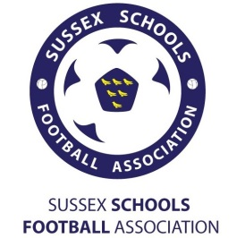
SUSSEX SCHOOLS FA
U15 Manager Aran Hawkins – 07708 503 504 Email – ahawkins@longhill.org.uk
Dear Headteacher/Head of PE/ Head of Year
This is to inform you of the Sussex Schools Year 10 (u15) Boys County Football trials which are to be held at Longhill High School, Falmer Road, BN2 7FR on Saturday 20th September 9am – 12pm
This particular age group were extremely successful this season getting through to the National Cup Final at The Madjeski missing out narrowly to Essex. To represent Sussex County Schools, players are required to be of an advanced standard so please select only those you feel are capable. Maximum of three per school to be nominated (unless you feel there really are more that are deserving of a trial). All players must be going in to year 10 in September 2014 to be eligible for selection.
Once you have selected them please inform the player/s and forward their information to this email. Further instructions will then be sent to the parent mobile number. You will be informed of any boys from your school that are successful in gaining a place in the new squad.
TRIAL DATE-
Saturday 20th September 2014
PLAYER  NAME | POSITION  PLAYED | PARENT CONTACT MOBILE NO | SCHOOL  ATTENDING | Professional Academy  Played for if any | Any other relevant info
Many thanks in anticipation,
Aran Hawkins
Sussex Schools u15s

