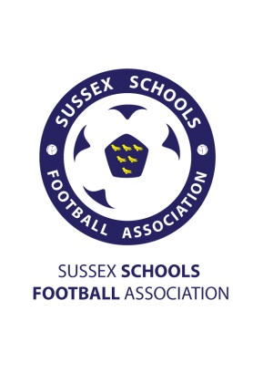
Sussex Schools FA
County Cup Finals 2016 – Sponsorship Tariff

Sussex Schools FA organise all schools Football across the county. We have around 100 schools and colleges that affiliate to our competitions and run 7 rep teams across U13-U18 age groups for both boys and girls. Our competition finals are being held at the Sussex County FA headquarters in Lancing and feature the best school teams from across the county.
We have ambassadors including Tommy Elphick (Bournemouth), Dean Hammond (Leicester/Sheffield Utd), Charlie Wakefield (Chelsea U21’s and England), Isaac Christie-Davies (Chelsea U21’s and England) and Tobi Adebayo-Rowling (Peterborough).
Our social media sites have over 2500 followers between them made up of people all across Sussex and includes most organisations that have a link to youth Football in Sussex.
Our website is visited frequently by all of our affiliated school users including staff, parents and students as there is updated information on competitions as well as breaking news in Schools Football. The hits on our website average around 2,000 a week but can spike as high as 10,000 when we have events such as finals, trials, announcements of ambassadors etc.
Attendance at our finals range between 200-300 people and we have 14 finals being played ranging from U12-U19 Boys/Girls.
*Sponsorship packages are to sponsor one final but may feature benefits across ALL finals as we use the same match program across all 14 finals. Also we have two finals per evening so having signs/boards up or flyers handed out will be for both finals on that night.*
Sponsorship Package 1 - £85
- Advert displayed in match programs across all finals
- Advert given out over the tannoy system stating you as the sponsor for the final, before the game, at half time and during the medal presentation.
- If you sponsor more than one final you will receive a £10 discount on additional finals.
Sponsorship Package 2 - £105 (As above but also including…)
- Option to have banners/boards/posters put up in prominent location inside the ground.
- Your business flyers handed out with each entry.
- Exclusivity for your type of business sponsoring our finals.
Sponsorship Package 3 - £125 (As above but also including…)
- At least 3 posts on each of our social media accounts
- A statement on our website announcing the sponsorship with an advert for your business
- Having the ‘player of the match’ award named after your business which will include a photo of the winner holding the trophy posted on our website mentioning your business again. (This will also be posted on social media accounts.)
- A photo with your banner/poster and one of our ambassadors who will be attending finals. (posted on website/social media).

