GDPR – General Data protection regulations
SSFA is legally required to inform you of the new government regulations. The General Data Protection Regulation (GDPR) is the new European legal framework for the protection of personal data. The regulation officially comes into effect on 25th May 2018. It comes in place of the 1995 Data Protection Directive (DPD) and, prior to Brexit, would have led to the UK implementing a new act in place of the existing Data Protection Act 1998.
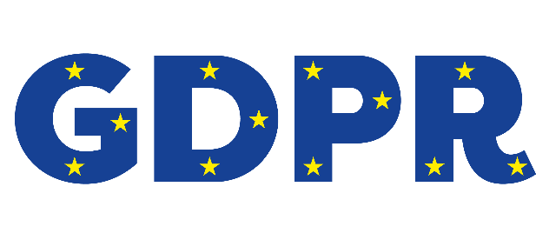
SSFA gains personal data from source:
- The data processor for SSFA is Genobi who is a third party independent business that is compliant with our policy.
- The data controller is Aran Hawkins (Vice Chairman SSFA)
- Your personal data is securely protected and encrypted;
- The purpose of this data collection is to obtain emergency contact details for the protection of the players and to communicate to the parents/carers about up and coming fixtures and events;
- The information will be stored for the duration of the season running from October to June in any given year. All information will be deleted at the completion of the season following the awards evening.
Parental/ Carers rights under the GDPR:
- You have the right to access your personal information at any time (SSFA will be able to send you your original registration information).
- The updating of personal information is the responsibility of the parent/ carer and can be done at any time FREE of charge by logging onto our database.
- You may ask to remove any specific personal data at any time by contacting aranhawkins@gmail.com
Management of your personal data:
- SSFA will hold the following information: your Child’s name/ DOB/ school they attend/ Medical and Allergy information and consent for the administering of anaesthetic in the case of the need for an emergency operation. SSFA will also hold the parents/carers emergency contact name/ telephone number/ email address and postal address. This is all classed as personal data;
- SSFA will use this personal data to contact you in an emergency, to contact you regarding payment of affiliation, upcoming fixtures and to inform of any upcoming events such as the end of season awards evening.
- SSFA is only collecting the relevant information required to be able to organise rep team Football over the course of the season.
- SSFA will not be using personal data to profile players or for any analysis of data.
- SSFA will retain personal information for one season from October until July.
- The parent and carer can with draw consent at any time by contact aranhawkins@gmail.com
- Our staff will be trained in the handling of data and they will sign a code of conduct in respect of this.

