DISTRICT AREA | SCHOOL TEAM | GIRLS | SMALL SCHOOLS
Brighton and Hove | Brighton College Prep | St Andrew’s Primary Hove
Crawley | Milton Mount | Three Bridges Junior school
Eastbourne | Ocklynge Junior School | Stone Cross Junior School
Hastings&District | Sedlescombe lhovenden | E Maynard (Catsfield)
Horsham&District | Southwater Junior Academy | Heron Way | St Peter's Cowfold
Lewes&District
Mid Sussex | St Wilfrid's CofE Primary School, | Lindfield Primary Academy | Bolney School
Worthing & District | Orchards Juniors school | West Park Primary School | Elm Grove Primary
West Sussex West | Throney Island | Bishop Tufnell Juniors | Funtington
District Primary Finals 2017/18

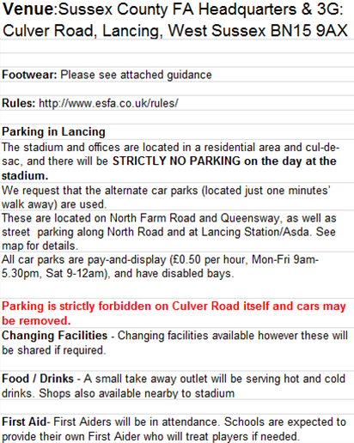
TIMINGS

SCHOOL TEAMS 9.30am -11.30am
GIRLS 12.30pm – 2.30pm
SMALL SCHOOLS 2.30pm – 3.30pm

Please note that the start time will be the time the first game starts. Lateness will result in forfeiting the match.
TIMINGS

