Under 16s Girls Squad 2019/2020

Mia King Cardinal Newman
Jasmine Moulding St. Richard’s Catholic College
Lily Betts The Weald School
Ruby Melis Blatchington Mill
Lucy Plumb Sackville
Alicia Macleod Hazelwick School
Katie Young © Ratton School
Poppy Bishop Sir Robert Woodard Academy
Millie Townsend Littlehampton Academy
Leonie Coleiro-Swain Causeway School
Katelon Goldsmith Durrington High School
Maddie Hotston Littlehampton Academy
Lottie Sharp Uplands CC
Nicole Mackay The Weald School
Chloe Nye Bexhill High
Brooke Nicholson-Rogan Longhill School
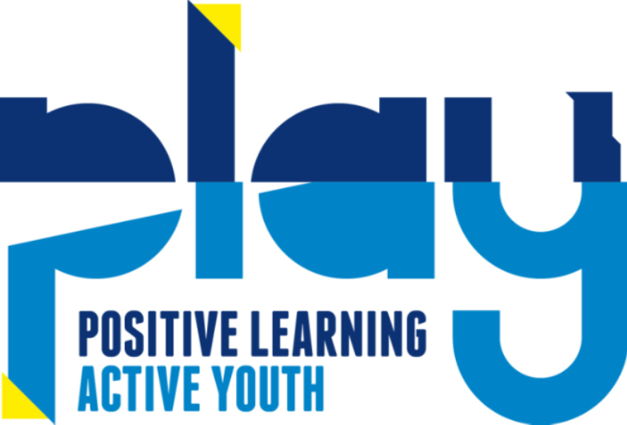
Katie Steer St. Catherine’s College

